Unit-2
Allocating Resources

Definition: What is Resource Allocation?
Resource allocation is the distribution of resources – usually financial - among competing groups of people or programs. Resource allocation arises as an issue because the resources of a society are in limited supply, whereas human wants are usually unlimited, and because any given resource can have many alternative uses. In free-enterprise systems, the price system is the primary mechanism through which resources are distributed among the uses most desired by consumers. In planned economies and in mixed economies, the decisions regarding resource distribution are taken by the combination of government and the market.
When we talk about allocation of funds for healthcare, we need to consider three distinct levels of decision-making.
Level 1: Allocating resources to healthcare versus other social needs.
Level 2: Allocating resources within the healthcare sector.
Level 3: Allocating resources among individual patients.
An Example of Resource Allocation
Let's consider an example: A community receives a gift of $100,000 from a wealthy donor to spend on healthcare, education and housing. The funds can be distributed among the three areas or dedicated to a single area, such as healthcare.
Level 1 : At this level, community members consider how to distribute the funds among one, two or three of the competing programs. For example, should the funding be split in three equal portions or should one program, possibly under-funded in the past, get all or most of the money?
Level 2 : Assuming that healthcare gets a portion of the $100,000, the next decision community members face is how best to direct the spending among competing healthcare interests. Should most or all of the funds go to hospital care and medical equipment? What about the public education program that promotes healthy lifestyles and behaviours (like exercise or immunizations) that prevent disease? Or, community members could decide to spend the money to purchase health insurance for those who can't afford it.
Level 3 : The next level of decision making involves distributing the financial resources among individuals.

Demand

Demand refers to the quantities of the product(goods or services) that buyers are willing and able to buy at various prices per period to time, “all other things being equal”. In layman language Demand is the desire to own anything, the ability to pay for it, and the willingness to pay during a specific period. Effective Demand is "the demand in which the consumer are able and willing to purchase at conceivable price"
simply saying if the product price is low more will buy if the rates went high the quantity of the demand goes down.

The relationship between demand and supply underlie the forces behind the allocation of resources. In market economy theories, demand and supply theory will allocate resources in the most efficient way possible. How? Let us take a closer look at the law of demand and the law of supply. 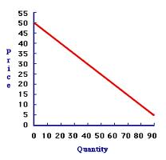
A. The Law of Demand
The law of demand states that, if all other factors remain equal, the higher the price of a good, the less people will demand that good. In other words, the higher the price, the lower the quantity demanded. The amount of a good that buyers purchase at a higher price is less because as the price of a good goes up, so does the opportunity cost of buying that good. As a result, people will naturally avoid buying a product that will force them to forgo the consumption of something else they value more. The chart below shows that the curve is a downward slope.
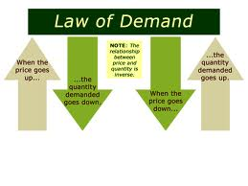
Movement in the demand curve
Movement in the demand curve occurs when the price of a product changes. For example, movement can occur if a candy manufacturer raises or lowers the price of a certain type of candy. Altering candy prices could cause consumers to buy more candy or less candy, depending on where the new price is set. The demand curve itself does not move; rather, there is movement along the curve.
Shift in Demand
The demand curve shifts when consumers change their perceptions about the worth of a product. If consumers decide they are willing to pay higher prices for a product or want to purchase more of it, the demand curve shifts to the right
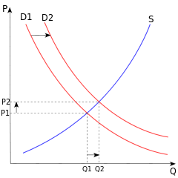
The price P of a product is determined by a balance between production at each price (supply S) and the desires of those with purchasing power at each price (demand D). The diagram shows a positive shift in demand from D₁ to D₂, resulting in an increase in price (P) and quantity sold (Q) of the product. The unit price for a particular good will vary until it settles at a point where the quantity demanded by consumers (at current price) will equal the quantity supplied by producers (at current price), resulting in an economic equilibrium for price and quantity.
Supply
Supply is the quantity that suppliers are willing and able to sell at at various prices per period of time, “all other things being equal”.
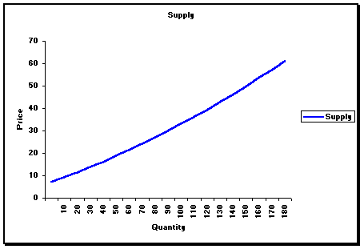

There is a direct relationship between price and quantity: quantities respond in the same direction as price changes. This means that producers are willing to offer more products for sale on the market at higher prices by increasing production as a way of increasing profits.

Shifts in supply
The position of a supply curve will change following a change in one or more of the underlying determinants of supply. For example, a change in costs, such as a change in labour or raw material costs, will shift the position of the supply curve. if costs rise, less can be produced at any given price, and the supply curve will shift to left.
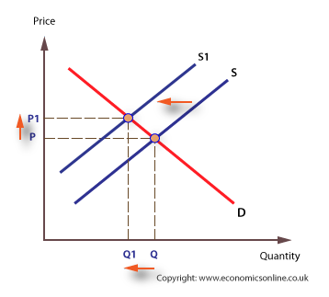

Equilibrium
When supply and demand are equal (i.e. when the supply function and demand function intersect) the economy is said to be at equilibrium. At this point, the allocation of goods is at its most efficient because the amount of goods being supplied is exactly the same as the amount of goods being demanded. Thus, everyone (individuals, firms, or countries) is satisfied with the current economic condition. At the given price, suppliers are selling all the goods that they have produced and consumers are getting all the goods that they are demanding.
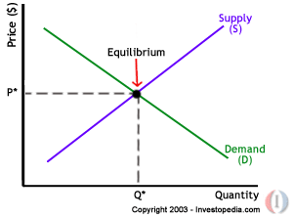

Law of Demand and Supply

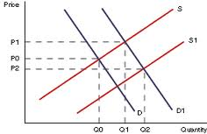
The four basic laws of supply and demand are:^{[1]}
- If demand increases and supply remains unchanged, a shortage occurs, leading to a higher equilibrium price.
- If demand decreases and supply remains unchanged, a surplus occurs, leading to a lower equilibrium price.
- If demand remains unchanged and supply increases, a surplus occurs, leading to a lower equilibrium price.
- If demand remains unchanged and supply decreases, a shortage occurs, leading to a higher equilibrium price

Factors Affecting Demand
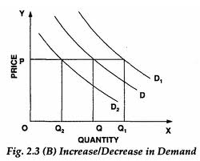
Causes for shift in demand for a product will be influenced by several factors:. The less consumers are willing to pay for a product, the more the demand curve shifts to the left. Usually viewed as the most important factor that affects demand. Products have different sensitivity to changes in price. For example, demand for necessities such as bread, eggs and butter does not tend to change significantly when prices move up or down. Other factor which affects demand are:
Income levels
When an individual’s income goes up, their ability to purchase goods and services increases, and this causes demand to increase. When incomes fall there will be a decrease in the demand for most goods. The effect that income has on the amount of a product that consumers are willing and able to buy depends on the type of good we're talking about. For most goods, there is a positive (direct) relationship between a consumer's income and the amount of the good that one is willing and able to buy. In other words, for these goods when income rises the demand for the product will increase; when income falls, the demand for the product will decrease. We call these types of goods normal goods.
However, for some goods the effect of a change in income is the reverse. For example, think about a low-quality (high fat-content) cheese. You might buy this while you are a student, because it is inexpensive relative to other types of cheese. But if your income increases enough, you might decide to stop buying this type of cheese and instead buy low fat cheese which is expensive than the normal cheese. If this were the case (that as your income went up, you were willing to buy less high-fat cheese), there would be an inverse relationship between your income and your demand for this type of cheese. We call this type of good an inferior good. There are two important things to keep in mind about inferior goods. They are not necessarily low-quality goods. The term inferior (as we use it in economics) just means that there is an inverse relationship between one's income and the demand for that good. Also, whether a good is normal or inferior may be different from person to person. A product may be a normal good for you, but an inferior good for another person.

Fashion
When a product becomes unfashionable, demand can quickly fall away. Changing tastes and preferences can have a significant effect on demand for different products. Persuasive advertising is designed to cause a change in tastes and preferences and thereby create an increase in demand. A good example of this is the recent surge in sales of Yoghurt.

This is a less tangible item that still can have a big impact on demand. There are all kinds of
things that can change one's tastes or preferences that cause people to want to buy more or less of a product. For example, if a celebrity endorses a new product, this may increase the demand for a product. On the other hand, if a new health study comes out saying something is bad for your health, this may decrease the demand for the product. Another example is that a person may have a higher demand for an umbrella on a rainy day than on a sunny day
The price of substitute and complementary goods
Competitors are always looking to take a bigger share of the market, perhaps by cutting their prices or by introducing a new or better version of a product. On the other hand, some goods are considered to be substitutes for one another: you don't consume both of them together, but instead choose to consume one or the other. For example, for some people Coke and Pepsi are substitutes (as with inferior goods, what is a substitute good for one person may not be a substitute for another person). If the price of Coke increases, this may make Pepsi relatively more attractive. The Law of Demand tells us that fewer people will buy Coke; some of these people may decide to switch to Pepsi instead, therefore increasing the amount of Pepsi that people are willing and able to buy. We summarize this by saying that when two goods are substitutes, there is a positive relationship between the price of one good demand for the other good.
Complementary Goods: Complementary goods are those whose use is directly related to the use of another product. An example of this would be the demand for hotdogs and hotdog buns. The supply and demand of hotdogs is represented by the figure at the right with the initial demand D1. Suppose that the initial price of hotdogs is represented by P1 with a quantity demanded of Q1. If the price of hotdog buns were to decrease by some amount, this would result in a higher quantity of hotdogs demanded. This higher quantity demanded would cause the demand curve to shift outward to a new position D2. Assuming a constant supply S of hotdogs, the new quantity demanded will be at D2 with a new price P2
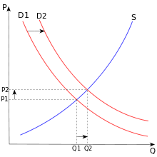
Supply and demand of Hotdogs
Other examples include : Printers and ink cartridges, DVD player and DVD’s, Computer hardware and computer software
Factors affecting Supply
- 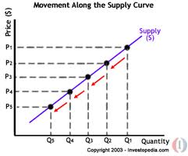
The supply of a commodity is the amount of commodity a producer is willing to put in the market at a given time at a given price. The factors affecting supply are
1. Price of the commodity- More the price of the commodity, more the supply and less the price of the commodity, less the supply.
2. Price of factors of production (e.g. land, labour) - More prices of factors of production results in less profit for the producer, therefore reduced supply. Rising resource prices lead to rise in production cost.
3.Price of related goods - If a producer sees more profit in another good, and if the producer is easily able to switch, it will start making the other good, thereby reducing the supply for the good in question.
Eg: If a farmer is currently growing wheat and he calculates more profit in growing barley, next year he will plant barley, thereby reducing supply of wheat.
4. Technology- The most significant factor here is the state of technology. If there is a technological advancement in one's good's production, the supply increases. Better technology allows for more efficient use of factors of productions
5. Environmental: Weather/Natural Disasters- Other variables may also affect production conditions. For instance, for agricultural goods, weather is crucial for it may affect the production outputs.
6. Subsidies and taxation: Government intervention can have a significant effect on supply. Government intervention can take many forms including environmental and health regulations, hour and wage laws, taxes, electrical and natural gas rates and zoning and land use regulations. And if the government decides to increase the production tax, there will be less profit so less supply And If government decides to subsidize a good, there will be more profit for producer so more supply.
7. Joint supply- Some products or production processes have more than one use. For instance, cows can both provide milk and be eaten. If farmers increase the number of cows they own in response to an increase in DEMAND for milk, they are also likely to increase, a little later, the supply of meat, causing beef prices to fall."

Price Elasticity of Demand
Elasticity refers to the degree of responsiveness in supply or demand in relation to changes in price. If a curve is more elastic, then small changes in price will cause large changes in quantity consumed. If a curve is less elastic, then it will take large changes in price to effect a change in quantity consumed. Graphically, elasticity can be represented by the appearance of the supply or demand curve. A more elastic curve will be horizontal, and a less elastic curve will tilt more vertically. Price elasticity of demand, also called the elasticity of demand, refers to the degree of responsiveness in demand quantity with respect to price. Consider a case in the figure below where demand is very elastic, that is, when the curve is almost flat. You can see that if the price changes from $.75 to $1, the quantity decreases by a lot. There are many possible reasons for this phenomenon. Buyers might be able to easily substitute away from the good, so that when the price increases, they have little tolerance for the price change. Maybe the buyers don't want the good that much, so a small change in price has a large effect on their demand for the good.
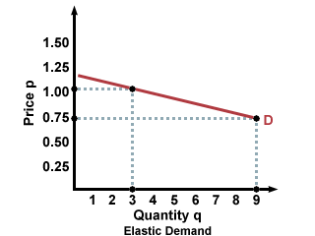
Figure %: Elastic Demand
If demand is very inelastic, then large changes in price won't do very much to the quantity demanded. For instance, whereas a change of 25 cents reduced quantity by 6 units in the elastic curve in the figure above, in the inelastic curve below, a price jump of a full dollar reduces the demand by just 2 units. With inelastic curves, it takes a very big jump in price to change how much demand there is in the graph below. Possible explanations for this situation could be that the good is an essential good that is not easily substituted for by other goods. That is, for a good with an inelastic curve, customers really want or really need the good, and they can't get want that good offers from anywhere else. This means that consumers will need to buy the same amount of the good from week to week, regardless of the price.
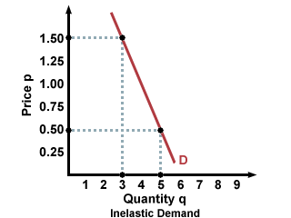
Figure %: Inelastic Demand
Price elasticity of demand (PED) shows the relationship between price and quantity demanded and provides a precise calculation of the effect of a change in price on quantity demanded. The following equation enables PED to be calculated.

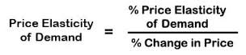

The range of responses
The degree of response of quantity demanded to a change in price can vary considerably. The key benchmark for measuring elasticity is whether the co-efficient is greater or less than proportionate. If quantity demanded changes proportionately, then the value of PED is 1, which is called ‘unit elasticity’.
PED can also be:
- Less than one, which means PED is inelastic. If the elasticity of the demand curve is less than 1, meaning the percent change in quantity is less then the percent change in price, then the curve will be steep and inelastic: it will take a big change in price to affect demand.
- Greater than one, which is elastic -If the elasticity of demand is greater than or equal to 1, meaning that the percent change in quantity is greater than the percent change in price, then the curve will be relatively flat and elastic: small price changes will have large effects on demand
- Zero (0), which is perfectly inelastic.

For example,(1) if the price of a daily newspaper increases from $1.00 to $1.20c, and the daily sales falls from 500,000 to 250,000, the PED will be:
- 50%
+ 20%
= (-) 2.5

The negative sign indicates that P and Q are inversely related, which we would expect for most price/demand relationships. This is significant because the newspaper supplier can calculate or estimate how revenue will be affected by the change in price. In this case, revenue at $1.00 is $500,000 ($1 x 500,000) but falls to $300,000 after the price rise ($1.20 x 250,000).

Note: If two goods are in joint demand they will have a high and negative cross elasticity of demand. – An increase in price of ink, will lead to a fall in demand for printers.

(2).Yesterday, the price of envelopes was $3 a box, and Julie was willing to buy 10 boxes. Today, the price has gone up to $3.75 a box, and Julie is now willing to buy 8 boxes. Is Julie's demand for envelopes elastic or inelastic? What is Julie's elasticity of demand?
To find Julie's elasticity of demand, we need to divide the percent change in quantity by the percent change in price.
% Change in Quantity = (8 - 10)/(10) = -0.20 = -20%
% Change in Price = (3.75 - 3.00)/(3.00) = 0.25 = 25%
Elasticity = |(-20%)/(25%)| = |-0.8| = 0.8
Her elasticity of demand is the absolute value of -0.8, or 0.8. Julie's elasticity of demand is inelastic, since it is less than 1.
Factors affecting price elasticity of demand
- The number of close substitutes – the more close substitutes there are in the market, the more elastic is demand because consumers find it easy to switch.
- The cost of switching between products – there may be costs involved in switching. In this case, demand tends to be inelastic. For example, mobile phone service providers may insist on a12 month contract.
- The degree of necessity or whether the good is a luxury – necessities tend to have an inelastic demand whereas luxuries tend to have a more elastic demand.
- The proportion of a consumer’s income allocated to spending on the good – products that take up a high % of income will have a more elastic demand
- The time period allowed following a price change – demand is more price elastic, the longer that consumers have to respond to a price change. They have more time to search for cheaper substitutes and switch their spending.
- Whether the good is subject to habitual consumption – consumers become less sensitive to the price of the good of they buy something out of habit (it has become the default choice).
- Peak and off-peak demand - demand is price inelastic at peak times and more elastic at off-peak times – this is particularly the case for transport services.
- The breadth of definition of a good or service – if a good is broadly defined, i.e. the demand for petrol or meat, demand is often inelastic. But specific brands of petrol or beef are likely to be more elastic following a price change.

Price Elasticity of Supply

Price elasticity of supply (PES) measures the responsiveness of quantity supplied to a change in price. It is necessary for a firm to know how quickly, and effectively, it can respond to changing market conditions, especially to price changes. The following equation can be used to calculate PES.
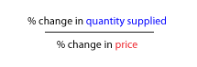
There are three extreme cases of PES.
- Perfectly elastic, where supply is infinite at any one price.
- Perfectly inelastic, where only one quantity can be supplied.
- Unit elasticity, which graphically is shown as a linear supply curve coming from the origin.
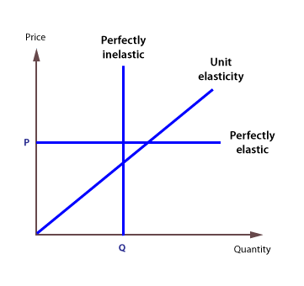
Consider the following example:
A firm’s market price increases from £1 to £1.10, and its supply increases from 10m to 12.5m. PES is:
=+25/10
= (+) 2.5
The positive sign reflects the fact that higher prices will act an incentive to supply more. Because the coefficient is greater than one, PES is elastic and the firm is responsive to changes in price. This will give it a competitive advantage over its rivals
Factors affecting elasticity of supply
Time: In the short run firms will only be able to increase input of labour to increase supply of commodities may not be able to increase the supply in response to the price change but the supply change will be little because other factors of production may not be increased in the same proportion and may limit the supply. However, in the long run a firm will increase the input of all factors of production and thus the supply becomes more price elastic.
Availability of resources: If the economy already using most of its scarce resources then firms will find it difficult to employ more and so output will not be able to rise. The supply of most of goods and services will therefore be price inelastic.
Number of producers: More producers mean that the output can be increased more easily. Thus supply is more elastic.
Ease of storing stocks: If goods can be stocked with ease and have a long shelf life, the supply will be elastic, otherwise inelastic. For example perishable goods such as fresh flowers, vegetables have comparatively inelastic supply because it is difficult to store them for longer periods.
Increase in cost of production as compared to output: In cases where there is a significant increase in cost of production when output is increased, supply is inelastic. This is because suppliers will have to have to do a significant investment in order to increase the output. It will take time and some suppliers may be hesitant in doing so.
Improvement in Technology: In industries where there is a rapid improvement in technology, the PES of such goods will be more elastic as compared to industries where there is not much improvement in technology.
Stock of finished goods: In industries where there are high inventories/stocks of finished goods, the suppliers can easily supply more as the price rises. Thus, the PES for these goods will be elastic.
Usefulness of Price elasticity of demand

Total Revenue
Total revenue is calculated as the quantity of a good sold multiplied by its price. It is a measure of how much money a company makes from selling its product, before any costs are considered. Obviously, the goal of a company is to maximize profits, and one way to do this is by increasing total revenue. The company can increase its total revenue by selling more items or by raising the price.

Why Elasticity Matters
Price elasticity of demand and total revenue are closely interrelated because they deal with the same two variables, P and Q. If your product has elastic demand, you can increase your revenue by decreasing the price of that good. P will decrease, but Q will increase at a greater rate, thus increasing total revenue. If the product is inelastic, then you can actually raise prices, sell slightly less of that item but make higher revenue. As a result, it is important for management to know whether its product has inelastic or elastic demand. Revenue is maximized when price is set so that the PED is exactly one.
Change in the market | What happens to total revenue?
Ped is inelastic and a firm raises its price. | Total revenue increases
Ped is elastic and a firm lowers its price. | Total revenue increases
Ped is elastic and a firm raises price. | Total revenue decreases

Taxation and subsidy policy:
The government can impose higher taxes and collect more revenue if the demand for the commodity on which a tax is to be levied is inelastic.
On the other hand, in ease of a commodity with elastic demand high tax rates may fail to bring in the required revenue for the government.
Govt., should provide subsidy on those goods whose demand is elastic and in the production of the commodity the law of increasing returns operates.
Exchange Rate
The price of one country's currency expressed in another country's currency. In other words, the rate at which one currency can be exchanged for another. The price elasticity of demand (PED) relates proportionate changes in price to proportionate changes in demand. When the exchange rate appreciates or depreciates, the relative prices of imports and exports change.

Merits of the Market System
The Market
A market is any place where the sellers of a particular good or service can meet with the buyers of that goods and service. An actual or nominal place where forces of demand and supply operate, and where buyers and sellers interact (directly or through intermediaries) to trade goods, services, or contracts or instruments, for money or barter.
Markets are places that bring together buyers and sellers. However, markets do not have to be physical places. Markets exist whenever and wherever buyers and sellers interact, be it a physical location, via mail, or over the Internet. Several conditions must be met in order for markets to function efficiently. Typical conditions for an efficient market include a large number of buyers and sellers acting independently according to their own self-interest, perfect information about what is being traded, and freedom of entry and exit to and from the market.
Government Role: The role of government is largely one of ensuring that the free market participants play fair and providing national infrastructure that everyone needs.
Regulations are required to some extent to prevent unscrupulous people from manipulating the system to gain an unfair advantage. For example, businesses are not allowed to conspire to keep prices higher than if competition were allowed to occur.
Of course, government also has a legitimate role in coordinating large projects for the common good: national defense, the interstate road system, aviation safety, etc. These are services which everyone relies upon and which, if they did not already exist, the public would eventually decide they would contribute to pay for to institute.

Merits of the Market System
- Free market responds quickly to the people’s wants: Thus, firms will produce what people want because it is more profitable whereas anything which is not demanded will be taken out of production.
- Wide Variety of goods and services: There will be wide variety of goods and services available in the market to suit everybody’s taste. A great variety of consumer goods become available for those who have the money to buy them;
- Efficient use of resources encouraged: Profit being the sole motive, will drive the firms to produce goods and services at lower cost and more efficiently. This will lead to firms using latest technology to produce at lower costs.
- Keeping Prices Down: Firms making goods which are more popular with consumers can sell them at competitive prices and earn profits. But producers who make unwanted products, or operate inefficiently and pay too much to make their products, will incur losses, eventually, they must either learn to produce and compete efficiently -making products consumers want at competitive prices- or they will go out of business, and someone else will takeover the market.
Market failure
An economic term that encompasses a situation where, in any given market, the quantity of a product demanded by consumers does not equate to the quantity supplied by suppliers. It occurs whenever markets fail to deliver an efficient allocation of resources and the result is a loss of economic and social welfare.
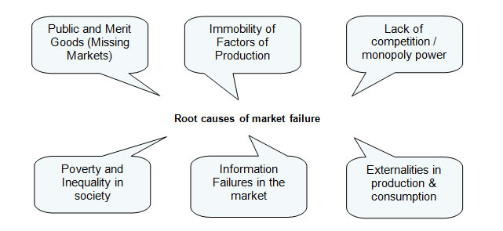
Complete and partial market failure
- Complete market failure occurs when the market simply does not supply products at all - we see “missing markets”
- Partial market failure occurs when the market does actually function but it produces either the wrong quantity of a product or at the wrong price.
Markets can fail for lots of reasons:
- Not producing public or merit goods
Public Goods: Public goods are goods which total cost of production does not increase with the number of consumers. Public goods will not be provided by the market.
Public goods are:
1. non-rivalrous (consumption by one consumer will not reduce the amount available for other consumers in the market, i.e. they do not have to compete to obtain the good/service) Something is non-rivaled if one person's consumption of it does not deprive another person, (to a point) a firework display is non-rivaled - since one person watching a firework display does not prevent another person from doing so.
2. non-excludable (no consumer is excluded from consuming such good/service). Something is non- excludable if its use is cannot be limited to a certain group of people. Again, since one cannot prevent people from viewing a firework display it is non-excludable
- The classic example is national defence
- Other examples: street lights, roads
Merit Good: Goods or services (such as education and vaccination) provided free for the benefit of the entire society by a government, because they would be under-provided if left to the market forces or private enterprise.
Under provision of merit goods: if left to its own devices, merit goods (a private good that society considers under consumed, often with positive externalities) will be underprovided. These are goods and services which have a positive effect on society like education, healthcare and sports center.
Over provision of demerit goods: if left to its own devices, demerit goods (a private good that society considers over consumed, often with negative externalities) will be overprovided. These are such things as prostitution, alcohol and cigarettes. To discourage these demerit goods the government creates: negative advertising, tax on the good, or bans it altogether
2. Factor immobility
Factor immobility occurs when it is difficult for factors of production (e.g. labour and capital) to move between different areas of the economy. Factor immobility could involve:
Geographical immobility – difficult to move from one geographical area to another.
Occupational immobility – difficult to move from one type of work to another.
3.Imperfect information or information failure –It means that merit goods are under-produced while demerit goods are over-produced or over-consumed
4. Market dominance by monopolies can lead to under-production and higher prices than would exist under conditions of competition, causing consumer welfare to be damaged.
5. Externalities: A side effect or consequence of an industrial or commercial activity that affects other parties without this being reflected in the cost of the goods or service involved. Consumers can create externalities when they purchase and consume goods and services. Externalities can cause market failure if the price mechanism does not take into account the full social costs and social benefits of production and consumption.
Negative externalities occur when production and/or consumption impose external costs on third parties outside of the market for which no appropriate compensation is paid.
- Smokers ignore the harmful impact of toxic ‘passive smoking’ on non-smokers
- Air pollution from road use and traffic congestion and the impact of road fumes on lungs
- The external cost of food waste
- The external costs of litter and the dropping of chewing gum
- Externalities created through the mis-treatment of animals
- Externalities arising from crime
Positive externalities This occurs when the consumption or production of a good causes a benefit to a third party.
For example, when you consume education you get a private benefit. But there are also benefits to the rest of society. E.g you are able to educate other people and therefore they benefit as a result of your education. A farmer who grows apple trees, provides a benefit to a beekeeper. The beekeeper gets a good source of nectar to help make more honey.
Therefore with positive externalities the benefit to society is greater than your personal benefit. Therefore with a positive externality the Social Benefit > Private Benefit
Note: Remember Social Benefit = private benefit + external benefit.
6.Poverty and Inequality issues. Markets can generate an ‘unacceptable’ distribution of income and consequent social exclusion which the government may choose to change
Every business activity which takes place has some benefits and costs attached to it. The benefits go both to the owners of the firm as well as to external stakeholders. In the same way the owners and the external stakeholders have to pay a cost for the activities of the business.
Talking about…

Private cost
It is the cost of setting up the business. The owner(s) pay for the hire of machinery, buying of materials, payments of wages. This is termed as Private Cost.

Private benefit
The monetary benefits i.e. the revenue earned by the firm is a benefit for the owner and is termed as Private benefit.

External Cost
The problems that the external stakeholders have to bear due to the firm’s activity are known as external cost. Example: cleaning a river which has been polluted by a firm’s waste products. Private firms usually ignore external cost.

External benefits
Some firms can cause external benefits. These are the benefits to the external stakeholders due to the activity of firm. For example, a firm may train workers, which might get them better wages in other firms. These external benefits are free.
Social cost
Social cost is the total cost paid for by the society due to the activities of a firm. It is the sum of all the external cost and private cost.
Social Cost = Private Cost + External Cost
Social benefits
Social benefit is the total benefit arising due to the production of goods and services by a firm. This is equal to the total of private benefits and external benefits.
Social Benefit = Private Benefit + External Benefit
When negative production externalities exist, social costs exceed private cost. This leads to over-production if producers do not take into account the externalities.
For example, a chemical plant installs machinery that increases output and reduces employment. The private costs of the extra output are the price of the new machinery. The private benefits are the increases in the chemical firm's profits and in consumption. The external costs include the effects of any increased pollution as a result of the increased output, and the effects of increased unemployment, such as higher expenditure on unemployment benefits. The external benefits include any improvements in technology that other firms can benefit from.
Conflict between private and social interests
A side effect or consequence of an industrial or commercial activity that affects other parties without this being reflected in the cost of the goods or service involved. It occurs between the parties who are likely to receive positive benefits and parties who will suffer from negative externalities. It can be illustrated by issues of
Conserving resources versus using resources
Resource conservation is the practice of trying to preserve as much of the natural world and its resources as possible. There are many ways that one can conserve natural resources. All you need to do is to look around and see what natural resources you are using and find out ways to limit your usage. Most of the people use natural gas to heat their water and their home. You can monitor how much you are using this resource to minimize its usage.
Natural capital is the land, air, water, living organisms and all formations of the Earth's biosphere that provide us with ecosystem goods and services imperative for survival and well-being.
Man-made capital- Capital goods are generally man-made in the form of factories, machinery, tools, equipment, roads, bridges and various buildings.
Social capital- Social capital can be defined simply as the existence of a certain set of informal values or norms shared among members of a group that permit cooperation among them. It can be the form of relationships between members of society such as family and community.
Conflicts usually arise between businesses seeking to develop new factories, roads and mines and the society, local communities seeking to conserve natural capital.
Public expenditure versus Private expenditure
Public expenditure is a type of spending usually done by firms in the public sector, or government organisations, examples include: building of schools, dams, public and merit goods. Whereas, private expenditures are carried out by firms in the private sector of an economy, who have their main motive as profits. Examples of these expenditures include: setting up a factory, or expansion of a profitable outlet. There is always conflict between the two those who are in favour of public expenditure feels that

1. Public spending can improve the infrastructure of an economy
If the spending is on capital items, then infrastructure can be developed, which can help improve competitiveness and economic growth.

2. Public spending can generate positive externalities
Spending on infrastructure, healthcare, and education also provides an external benefit to the rest of the economy
Those who are in favour of Private expenditure they argue that
  - Individuals should not pay any taxes, as is their money and they should have right to spend their money in their own way because they think that government doesn’t know properly how individuals would like to spend that money.
  - Sometimes, the expenditure made by the government can be wasteful too.
___________________________________________________________________________

