Section B (Practical Questions: 60 minutes)
You work for a company called MyatThu Global Computer Company. You will create a stylesheet and then edit a webpage, which promotes the company.
1. Create a stylesheet defining all colors using hexadecimal values and the following styles:

Style
body | Background | Color red FF, green FF, blue 0
H1 | Font face | First choice: Arial Rounded MT Bold  Default: the browser’s default sans-serif font
 | Color | Maximum blue with no other color components
 | Alignment | Centre
 | Size | 48 pixels
H2 | Font face | First choice: Arial
 | Color | Blue A0, Red 00, Green 00
 | Alignment | Left
 | Size | 24 pixels
 | Weight | Bold
p | Font face | The browser’s default serif font
 | Color | Black
 | Alignment | Fully justified
 | Size | 14 pixels
Li | Bulleted | Bullet shape as a solid square
 | Alignment | Left
2. Add your name at the bottom of your stylesheet as a comment.

3. Save your stylesheet as MidTern2019.css.

3. Create a webpage using html code and the output should be the same as the given image.

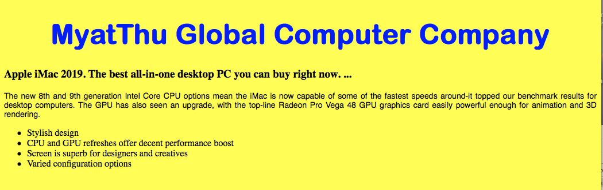

[50]

End of paper

